Automated Hand Sanitiser Dispenser

Design Portfolio

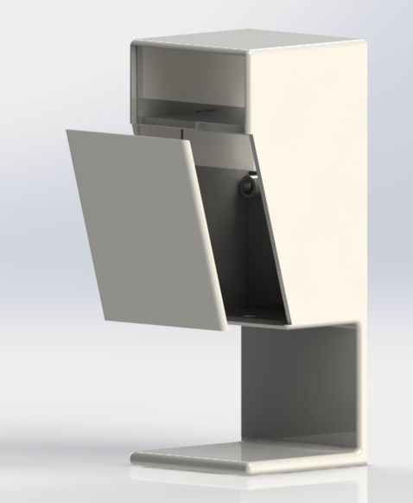

Group 8

Alison Kennedy

Liviu Nastase

Ryan Lacey

Shane Cawley

Contents

Introduction **3**

Product Design Specification (PDS) **5**

Problem Breakdown & Concept Development**12**

Selection of Optimum Solutions **15**

Detailed Design **26**

Failure Modes and Effect Analysis (FMEA) **32**

Conclusions **36**

References **37**

Appendices38

Figure Listing

**Diagram A**

# Introduction

The objective of the project at hand is to design an intelligent automated dispenser for hand sanitising purposes. This device (automated hand sanitiser dispenser) shall be a networked device that is connected to a centralised management system.

Our design will be kept relatively universal. We will attempt to strike the perfect balance between cost-efficiency, and innovation maximisation. By this, we mean to say that our team has attempted to keep profitability in mind while also creating the most innovative and efficient design.

Our team is multidisciplinary, composed of four members from three very different schools, which are; The School of Computing (Alison Kennedy - Computer Science Manager), The School of Electronic Engineering (Liviu Nastase - Electrical Engineering Manager), and The School of Mechanical & Manufacturing Engineering (Ryan Lacey - Design Engineering Manager, & Shane Cawley - Mechanical Engineering Manager).

Through in-depth teamwork, we have come up with the following Design Portfolio), which has the sole aim to summarise the project at hand and develop a clear understanding of how our team went about constructing the device specified in the design brief, which follows this paragraph.

The design brief was posed as follows.

Design an “intelligent automated dispenser for hand sanitising purposes. This device (automated hand sanitiser dispenser) shall be a networked device that is connected to a centralised management system.”

* The device should be wall-mounted or free-standing.
* The device should be easy to install, and equally as easy to replace or refill.
* The device should dispense a remotely controllable, finite volume of liquid, achieved through networking.
* The device should have two sets of proximity sensors. One to detect when a person is in the surrounding area (in which case a beacon should flash to alert possible users of its presence), and the other to detect when a user intends on using the device for its intended purpose (therefore, the device should work without the user having to physically touch it, through use of these electrical proximity sensors).
* The device should be smart (should be networked and controlled remotely). This shall be achieved through the use of a Raspberry Pi single-board computer (which will allow sensors to be read, dispensing motors to be controlled and data to be sent to a central server over the internet).
* The device should report all usage data to a central database for analytics (for example, number of uses per hour). Through this reporting, a warning message should appear when the level of the sanitising solution falls below a predetermined level, which is based on the usage levels for that particular device.

In order to reach this stage of the design process (the Design Portfolio), a number of steps were completed in an eight week period. Our multidisciplinary team was brought together with the common goal of completing the task at hand to the best of our abilities.

Our company, ALRS, has an underlying passion for efficiency in all areas, from cost to time to material (environmental). We strive to provide the best products on the market in the most efficient manner, while keeping our designs as environmentally friendly and cost effective as is possible, while maintaining a perfect standard.

Our hand sanitising dispenser is no exception to these underlying passions. These standards and specifications were achieved through use of various softwares, including (but not limited to) Solidworks drawing software, CES material selection software, Fritzing electronic circuit diagram software, and Sublime text editor software to write the Python code. These softwares were complimented also through the accomplishment of many deliverables up until this date, including a Product Design Specification, a Patent search & Literature review, and an API configuration.

This device was designed with some clear cut goals;

* Efficiency maximisation (through active teamwork).
* Cost minimisation (through bulk purchasing, and correct manufacturing).
* Environmental friendliness (through an absolute minimisation of waste).
* Ease of installation & use.

We can proudly say that the device we are going to present to you today matches the highest of standards, from a medical device perspective all the way to a physical aesthetics perspective. We took absolute care in designing, (virtually) manufacturing, circuiting and coding the device to absolute perfection.

Without any further hesitation, here is an overview of the device.

|  |  |  |  |
| --- | --- | --- | --- |
| Design | Mechanics | Electronics | Computer |
|  | **Wall mounted**  **Material: ABS**  **Servo Motor**  **Rack & Pinion**  **Injection Moulding** | **Mains Electricity**  **Servo Motor** | **Python**  **Network API**  **TCP sockets Bi-directional**  **Web App** |

# Product Design Specification (PDS)

The Product Design Specification (PDS) is a very important document in the design process as it contains all the information necessary for a design team to successfully produce a solution to the design problem. [1]

Our PDS was composed in the very first week of this project, in which we defined as many of the project's outcomes and end results as possible. In order to compose a PDS, we numbered a range of performance criteria from 1 to 32 (in no particular order), in which all 32 points are essential to the successful completion of the project at hand.

1. **Performance**

The device will be used to automatically, through the use of sensors, dispense hand sanitising solution to those who activate said sensors. This means that the sanitising solution should be dispensed without physical user intervention, but rather through signal input obtained through proximity sensors.

The device should dispense a finite amount of solution per use, and should attempt to minimise waste.

The device should alert potential users (of its presence) in the surrounding area in order to maximise usage.

The device should alert the operator when a refill is necessary. When a refill is necessary, this process should be done with ease. The sanitiser itself should be bought from an external company (i.e. the device is non-refill, but rather replacement). Hopefully, there is an international standard which we can use (rather than iPhone Vs Android). This means the solution cannot be contaminated (we will make use of a sealed container, where the seal is only broken once incorporated into our device).

The devices will form a centralised network with a central server. All usage data shall be recorded and reported to a central database to allow for analysis by algorithms. The purpose of this is again to maximise usage.

1. **Environment**

The device will be used indoors (hospitals, schools, businesses), at normal pressure, temperature and humidity. It will be mounted on walls, the materials used must be of adequate quality to prevent the premature wear of the dispenser due to high usage.

1. **Life Span**

The device should have a lifespan of a minimum of 3 years, providing that necessary maintenance (cleaning, both internal and external) is carried out. The main concern would be wear on the parts or an electrical fault. The onboard computer (raspberry pi) has a typical lifespan of 10 years at constant use. The device should be durable enough to withstand heavy, regular use.

1. **Maintenance**

Maintenance should be minimal. The act of installing the device should be as easy as installing a wall mount (positioned using adhesive strips, and secured using screws). The act of refilling (replacing) the sanitising solution should be completable with absolute ease. The act of cleaning the device shall be as simplistic as cleaning any other household device/amenity, such as a sink or a tabletop. The only software update requirements in the product itself will be for unexpected bug fixes. New features or statistics will be achieved through data processing algorithms on the central server.

1. **Target Product Cost**

Based on the brief and the primary usage of the device, the cost should be relatively small for such a dispositive with the required specifications. The materials used (Primarily Acrylonitrile Butadiene Styrene) are relatively cheap (Typically no more than €1.50 per pound), while the implementation of the smart capabilities and the collections of data with the processing will add cost to the final product.

1. **Competition**

There are a wide variety of automatic sanitizers already on the market and in use in hospitals and businesses. They range in function and price from basic gel dispensers to hospital-grade atomisers.

1. **Shipping**

The transportation of this particular device is currently limited to use in Dublin City University.

1. **Packing**

The device should be packaged securely to ensure it is not damaged in transit. Sustainable materials should be used for the packaging where possible and all of the necessary paperwork should be included. It is important that a detailed instruction manual is provided to ensure the device is used correctly.

1. **Quantity**

1 (The device shall come fully assembled. The only changes to be made over time will be in terms of refilling, which will be as simple as replacing the sanitising solution. This replacement will be bought separately).

1. **Manufacturing**

The hand sanitiser container will be made out of Acrylonitrile butadiene styrene (ABS), which is used due to a variety of properties which are ideal for the manufacture of this type of device. The housing of the electrical equipment will be made out of hard and durable plastic.

The processes available:

* 3D printing
* Injection Moulding (Injection Moulding Temperature of ABS: 204-238 °C)

1. **Size**

The device should be a fairly compact design, while still having enough space inside to fit all of the components inside the enclosure, as well as enough room for a reservoir for the sanitizing gel/liquid.

1. **Weight**

The device must be light enough to be wall-mounted. On average, the typical wall-mounted sanitising solution dispenser holds no more than 1 litre of solution. Our device will be manufactured from Acrylonitrile butadiene styrene (ABS), which has a density of no more than 1.5 g/cm3.

Therefore, the device weight plus the solution weight shall amount to no more than two kilograms.

1. **Aesthetics, Appearance, Finish**

An LED should flash when a person is at a certain distance from the dispositive to act as a reminder. Due to the purpose of the dispositive, it should look sterile to provide trust.

Acrylonitrile butadiene styrene (ABS) can be finished very nicely. It is a plastic that can be painted and filed to absolute perfection.

1. **Materials**

The device will mostly be made from durable plastic parts using Acrylonitrile butadiene styrene (ABS). ABS is cheap, resistant to corrosive chemicals (ethanol), and thermoplastic (and therefore easy to machine - injection moulding). The tubing for the sanitiser will be made from PET (polyethylene terephthalate), as this is the typical material used for containing corrosive substances like Ethanol.

1. **Product Lifespan**

Through the use of ABS as the material, the device shall last for up to and exceeding three years. The typical lifespan of raspberry pi, the main computer onboard the dispenser, is 10 years, running on a 24/7 basis.

1. **Standards and Specifications**

3D modelling should be used in the testing phase. All individual parts and assembly drawings in three-dimensional perspective are required for the final design. The dimensioning must be clearly defined with a definite error margin due to the modular design required.

1. **Ergonomics**

Even though users will not be touching the device, care must still be taken when designing the placement of the sensor to ensure the dispenser will only activate when someone’s hand is directly below the dispensing nozzle.

1. **Customer**

The general public, from hospital workers to university students, and everything in between.

1. **Quality and Reliability**

The dispenser will be modular, which will increase the lifespan. The individual parts which compose the assembly must be to a high standard but with a simple design. The final product will be formed from 2 or more parts which can be swapped in case something is not working properly.

1. **Shelf Life**

The shelf life of all of the parts will be a minimum of 3 years. After this time, the modular design will allow the parts to be replaced as needed.

1. **Processes**

* Fabrication (Injection moulding)
* Circuit design (to allow for sensor communication)
* Software design and development (for the computer and networking of the product)

1. **Time-scales**

All the aspects of the project must be completed in the following eight weeks, with a deadline of Friday 26th of June. The building and testing cannot be done in the given timeframe. However, there is a small time frame for the network aspect of the product to be tested on a small scale.

1. **Testing**

The circuitry and network functionality of the device will be tested separately to the mechanical elements of the device before they are tested together to simulate real-world use. Testing of the network functionality will be simulated using virtual Linux machines as a host and a client.

1. **Safety**

The device shall comply with all medical device regulatory bodies. These regulations will not be as severe as an invasive medical tool, such as a needle tip or a stent graft, but typical precautions, such as smooth edges, should be complied with.

1. **Company Constraints**

Supervision by mentors (professionals in their field) will be required during certain parts of the development sections. Testing the system on a large scale (such as that which would exist in hospitals) will not be possible at this stage due to hardware constraints.

1. **Market Constraints**

In a market with existing devices that serve the same purpose, one of the main market constraints is cost. Devices of this nature exist over at a wide range of prices and keeping overall costs down will ensure a marketable product.

1. **Patents, Literature, Product Data**

This type of device is very widely used, making it very hard to declare a hard patent. Many examples and samples of this type of device can be found online and in the workplace, especially given the current times we are living in (COVID-19 pandemic). Patenting the software involved in this product is non-conventional.

1. **Political and Social Implications**

***Social:***

The ultimate goal of the product is to reduce the spread of illness through social contact. By using the product, individuals put themselves and their close contacts at a lower risk of contracting bacteria and viruses (namely, Covid-19). The introduction of this product in schools, hospitals, businesses etc. may result in users feeling safer in those environments than before. Thus, boosting productivity in those environments.

***Political:***

If the product is successful in reducing the rate of spread of infection, this will directly affect the government’s actions in reducing lockdown restrictions.

1. **Legal**

While a device of this nature would not be classified under EU’s Medical Device Regulations, it is still important that the design is compliant with all of the necessary regulations and that the device is safe to be put on the market.

1. **Installation**

The device shall be installed with absolute ease. The device will be positioned on the desired wall through the use of two double-sided adhesive strips placed at the back of the device, in specifically indicated positions. Once positioned, the user will be able to drill (two) holes in each of the screw holes. Once these holes are drilled (using any form of electrically powered drill), the screws can be screwed in using a screwdriver.

We will provide the 2 double-sided adhesive strips and the 2 screws. The correct drill bit and the correct screwdriver will be a recommended add on per purchase (rather than per unit), so that those who buy in bulk, for example, 200 units, do not end up with 200 screwdrivers. All that will be required of the user is an electrically powered drill. If not owned, these can be purchased from €10 at any hardware store.

The technical aspect of the product will be ‘plug and play’. The user will not need to alter the program code in any way.

1. **Documentation**

The final documentation is required to be submitted by week eight. A software functional specification is required by the middle of week five. The final portfolio will include all the technical information, drawings and software. All the decisions which were made will be explained in there and the alternative options.

1. **Disposal**

The device should be made with as many recyclable materials as possible as well as materials that can be disposed of easily and safely. All of the necessary guidelines for the disposal of the design should be included in the instruction manual or a separate pamphlet packaged with the device.

ABS is what the device will be primarily composed of, which is an extremely recyclable material due to its thermoplastic nature.

# Problem Breakdown & Concept Development

In order to break the problem into component elements, and discuss how solutions were obtained, we must have a very good understanding of exactly what the design brief has instructed. From this brief, all possible problems can be broken down, and conceptual solutions can then be developed.

So once again, the design brief is as follows.

Design an “intelligent automated dispenser for hand sanitising purposes. This device (automated hand sanitiser dispenser) shall be a networked device that is connected to a centralised management system.”

* The device should be wall-mounted or free-standing.
* The device should be easy to install, and equally as easy to replace or refill.
* The device should dispense a remotely controllable, finite volume of liquid, achieved through networking.
* The device should have two sets of proximity sensors. One to detect when a person is in the surrounding area (in which case a beacon should flash to alert possible users of its presence), and the other to detect when a user intends on using the device for its intended purpose (therefore, the device should work without the user having to physically touch it, through use of these electrical proximity sensors).
* The device should be smart (should be networked and controlled remotely). This shall be achieved through the use of a Raspberry Pi single-board computer (which will allow sensors to be read, dispensing motors to be controlled and data to be sent to a central server over the internet).
* The device should report all usage data to a central database for analytics (for example, number of uses per hour). Through this reporting, a warning message should appear when the level of the sanitising solution falls below a predetermined level, which is based on the usage levels for that particular device.

From the design brief above, one can identify exactly which problems need to be solved. There are of course, however, other problems which the brief does not specifically question. Issues such as material choice, dispensing mechanism choice, code language choice, electric circuit diagram manufacturer choice, and so on, are not asked specifically. These are known as sub-problems, as they arise when attempting to develop a solution to a bigger problem.

The **problem breakdown** was defined as follows:

**Physical Design**

1. Design 1 or Design 2 (Designs can be found in Appendices, under “technical drawings”)
2. Wall Mounted or Free Standing

**Mechanical Design**

1. How to manufacture device
2. Material to be used for manufacture
3. Mechanism to be used to dispense liquid

**Electrical Design**

1. Power usage (battery or mains electricity)
2. Stepper or servo motor
3. Level monitor
4. Sensors
5. Display

**Computer Design**

1. Web app or Phone app for communicating with the device
2. Network API - how the device will communicate with a central server
3. Technology compatibility

Each problem caused our team to act towards the **concept development** to solve these problems (Note that this section is very similar to the problem breakdown, as all we did when developing concepts was identify the broad forms of solving the problem at hand. It was not until the selection of optimum solutions that we began to cross-analyse each potential solution).

**Physical Design**

1. Mechanical Engineers sat together and drew out many many many different designs
2. Wall Mounted or Free Standing

**Mechanical Design**

1. Additive, subtractive, or formative manufacturing
2. CES Materials software used in order to generate a material
3. Pneumatic actuator, electronic actuator, etc

**Electrical Design**

1. Power usage (battery or mains electricity)
2. Stepper or servo motor
3. Level monitor
4. Sensors
5. Display

**Computer Design**

1. Formulation of wireframes
2. Background research conducted into all 3 major options
3. Experimentation with different commonly used technologies

# Selection of Optimum Solutions

From the concept development, optimum solutions could be developed through matrix analysis of each conceptual solution to each problem.

**Physical Design**

**Problem 1 - Design 1 or Design 2**

As can be seen following, upon a design brainstorm, our team narrowed our design down to two possible designs. Each design posed with it some positives and negatives. Through matrix analysis, we were able to accordingly weight what we believed to be important, and therefore come to a conclusion of which design would best suit our requirements.

Both designs are composed of two separate housings, one for the mechanical elements and one for the electrical.

The electrical housing will hold the raspberry pi computer, the electronic circuit board, and the appropriate wiring which go to and from the power source, to and from the LED display screen, and to and from the mechanical servo motor mechanism which allows liquid to leave the device.

The mechanical housing will hold the hand sanitiser bag, as well as the mechanical servo motor mechanism which will pinch the bag opening to allow sanitiser to vacate the bag.

Both of these housing compartments will be easily accessible through use of hinges placed at critical points along the devices edges. This will allow for very easy access in order to maintain both the electronic parts as well as the mechanical, while keeping them separate.

|  |  |  |  |
| --- | --- | --- | --- |
|  | Weight | Design 1 | Design 2 |
| Cost | 3 | 8 | 6 |
| Aesthetics | 2 | 8 | 2 |
| Ease of Manufacture | 1 | 7 | 7 |
| Ease of Installation | 1 | 7 | 7 |
| Ease of Use | 1 | 9 | 9 |
| Ease of Maintenance | 1 | 8 | 8 |
| **Total** |  | **71** | **53** |

Through the cross analysis of these two concepts, the optimum solution is found to be Design 1.

**Problem 2 - Wall Mounted or Free Standing**

Through the below matrix analysis, we can come to many conclusions..

Starting broad, the table indicates (through the weighted scale) that the device Cost will be of pinnacle importance, followed closely in the next band of importance by its aesthetics, which is followed closely again in the final (lowest) band of importance by its ease of Manufacture, Installation, Use and Maintenance. All aspects are important, however some are more important to this particular project than others.

On a slightly more narrow scale, the table indicates that a wall mounted device would be more cost efficient (as less material is required to attach a wall mount than to manufacture and deliver a stand), more aesthetically pleasing than a free standing device (as it takes up less space), and easier to manufacture (as there is fundamentally less to manufacture). The table also suggests that the two types of device would have equal results for ease of use (as they serve the exact same purpose, and the main device would be the exact same regardless of how it is put in place) and for ease of maintenance (as they are maintained in exactly the same way, regardless of device design. One area in which the free standing device outperforms the wall mounted device is in ease of installation (as for a free standing device it’s simply put in a place, where a wall mount must be stuck on and drilled in).

Each number in the above table can be justified also (i.e. 9/10 for ease of installation for free standing device, as 100% of people would be able to install this device upon arrival. In the same category, the wall mount lands a 7/10, as there are screws and a power drill involved).

Finally, on the most narrow scale, the conclusion can be drawn that the use of a wall mounted device is massively more desirable than a free standing device.

|  |  |  |  |
| --- | --- | --- | --- |
|  | Weight | Wall Mounted  (/10) | Free Standing  (/10) |
| Cost | 3 | 8 | 4 |
| Aesthetics | 2 | 7 | 3 |
| Ease of Manufacture | 1 | 7 | 5 |
| Ease of Installation | 1 | 7 | 9 |
| Ease of Use | 1 | 8 | 8 |
| Ease of Maintenance | 1 | 5 | 5 |
| **Total** |  | **65** | **46** |

Through the cross analysis of these two concepts, the optimum solution is found to be wall mounted.

**Mechanical Design**

**Problem 1 - How to manufacture device**

Formative (Injection moulding), additive (3-D printing) or subtractive (CNC Machining).

Of the above three options, we must choose one. This choice is aided by matrix analysis.

|  |  |  |  |  |
| --- | --- | --- | --- | --- |
|  | Weight | Formative | Additive | Subtractive |
| Ease of Manufacture | 4 | 7 | 8 | 8 |
| Cost | 4 | 9 | 7 | 4 |
| Environment | 2 | 8 | 7 | 2 |
| **Total** |  | **80** | **74** | **52** |

As can be seen from the above matrix table, the desirable manufacturing process to use for this device is Injection Moulding.

Note: Other than the manufacturing of the physical device, there will also be a number of small parts associated. These include;

* 2 L-brackets (attached by us before sold to customers)
* 4 Screws (2 attached by us, and 2 included for the wall mount)
* 2 Adhesive strips (attached by us. Customer required to peel off protective strip)
* 4 Hinges (Attached by us. Will be used to open and close the housings)

**Problem 2 - Material to be used for manufacture**

The CES software was used to aid our decision making process in this regard, but was not the only persuasive factor. What was taken as more important than this ideal choice software was the practical idea of utilising the background information.

Extensive research was undertaken, where many hours were injected into the investigation of the most commonly used material for this particular type of device.

Through use of **CES software**, and through background research of current designs of similar devices, this material choice was shortlisted to; ABS Plastic, PVC Plastic and PP Plastic.

As can be seen below, these were cross-analysed through use of matrix analysis. This matrix analysis allowed us to come to a relevant conclusion of what material would be used for the manufacture of our device.

|  |  |  |  |  |
| --- | --- | --- | --- | --- |
|  | Weight | ABS Plastic | PVC Plastic | PP Plastic |
| Compatibility | 3 | 9 | 7 | 5 |
| Cost | 2 | 4  $1.15-$1.25 per pound | 9  12.44 cents per pound | 9  12.47 cents per pound |
| Ease of Maintenance | 2 | 8 | 8 | 8 |
| Ease of Manufacture | 1 | 8 | 4 | 3 |
| Density (Weight) | 1 | 8  1.07 g/cm3 | 7  1.38 g/cm3 | 9  0.855 g/cm3 |
| Environment | 1 | 8  Thermoplastic | 8  Thermoplastic | 8  Thermoplastic |
| **Total** |  | **75** | **74** | **69** |

**Legend:**

**Acrylonitrile butadiene styrene (ABS)**

**Polyvinyl chloride (PVC)**

**Polypropylene (PP)**

As can be seen from the above matrix evaluation of the three narrowed-down materials, the ideal material to use would be ABS plastic.

**Problem 3 - Mechanism to be used to dispense liquid**

Our options here came down to either the use of a pneumatic cylinder, or more simply, an electric servo motor positioned around the tip of the bag of sanitising solution (which will act in the same way that your fingers do when pressing in on a bicycle tyre air release valve).

For his decision, matrix analysis was not required. It can be quickly and easily concluded that a servo motor positioned about the nozzle of the sanitising solution bag would be a much more precise option (as servo motors respond very well to changes in current, while pneumatic cylinders respond only to changes in air input). A servo motor also works with very high efficiency, in that it takes very little electricity to be powered.

A servo motor output shaft can be moved to a particular position, at a particular velocity. Even a regular motor does not have this kind of precision. This is because a servo motor utilises both a regular electric motor, as well as a feedback sensor, coupled with a controller.

What’s more is that for a pneumatic cylinder mechanism to be implemented, we would need a compressed air supply - which is yet another factor that leads to an increase in costs, and a difficulty in device maintenance.

Through the utter precision exerted by this device, we can ensure that a very precise amount of hand sanitising solution is dispensed each time, regardless of how full or empty the bag of solution is.

There is the potential that the solution will dispense slower as the bag empties (as pressure reduces on the bag opening as the solution empties), however this would be quite minimal, and easily solvable through a small update in the software to allow the servo motor to actuate for slightly longer as the bag empties.

So to summarise, we are using an electric servo motor to generate circular motion. This circular motion will be transferred to linear motion through use of a simple rack & pinion mechanism.

The rack of said mechanism will lay normally in a non actuated position in line with the opening valve of the dispensing liquid. When the motor is activated, the rack will actuate out, and will come into contact with the valve of the bag of liquid. Once some pressure is introduced (there will be a stopper on one side, and the rack on the other), the liquid will start to dispense (like when two fingers create pressure around a bicycle tyre valve, air escapes. The principle is exactly the same).

What is important to note about the hand sanitising solution bag we are using is that it has a unique selling point of a valve that, when squeezed, allows liquid to vacate the bag in a constant fashion. For this reason, the simple clasp motion around the valve head between the rack and the solid plastic stopper will be enough to allow a constant, measurable amount of sanitising liquid to vacate the bag.

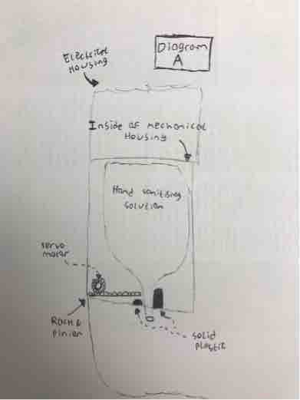

**Electrical Design**

**Problem 1 - Power usage (battery or mains electricity)**

**Power usage:**

|  |  |  |
| --- | --- | --- |
|  | Current | Voltage |
| Distance sensor | 15mA | 5V |
| Motion sensor | 65mA | 4.5-12V |
| Display | 2000mA | 5V |
| Four photoelectric sensors & LED | 40mA | 2-4V |
| Raspberry pi | 160mA | 5V |
| Buzzer | 30mA | 4-8V |
| **Total** | **2310mA** | **2-8V** |

As can be seen in the power usage table, the power consumption is quite large. To keep all the functionality of the device, it can not be powered with batteries. The most efficient way to power the device is to be plugged into the main power supply to have a constant feed of electricity. Due to the construction of the dispositive, the main power adaptor should be external (like the one used for laptops). This solution to separate the main power supply from the dispositive it will help with the servability of the device and reduce the cost of the repairs in case of a failure. Also, the power supply will include all the certifications and protections that will reduce the cost in order to obtain them.

The power supply should have a rating of 5V with 2.5 A. It is important to be able to provide more current than is required in order to not have any issues later on.

**Problem 2 - Stepper or servo motor**

Stepper motors have a high-speed, high torque and a high accuracy. Due to the way stepper motors are constructed, they also are light. The only drawback is that they need to be connected to a PWM signal in order to be a drive or another system which is compatible.

The servo motors are ideal for application with low speed, low torque and low accuracy. A big advantage is that they can be run open-loop, which means reduces the cost of using a PWM capable board.

Stepper motors are cheaper, compact, lighter and more suitable than the servo motors in the context of our device.

**Problem 3 - Level monitor solution**

For measuring the level of the liquid remaining, we will use a setup made out of 4 photoresistors in combination with an LED. The LED will help the photoresistors to read the liquid level.

**Problem 4 - Detection sensors**

The Ultrasonic sensor will be used in order to trigger the release mechanism of the substance while the Motion sensor will be used to count the number of people who pass the dispositive. The reasons to use 2 different types of sensors are the complexity and the costs associated.

**Problem 5 - Display**

The pi zero w supports mini-HDMI, that means for the testing we will be able to use a mini-HDMI to HDMI cable in order to connect the display. Also, the display requires additional power via an USB port which can be found on the pi as well.

**Computer Software Design**

**Problem 1 - Web app or Phone app for the user to communicate with the device**

As the system is designed for use in educational, healthcare and commercial settings, it is essential that the system has a Graphical User Interface (GUI). The GUI will allow the user/operator of the system to add a new device to their network, view device data, change the amount of fluid dispensed by each device,and receive notifications when a device has gone offline or has low fluid etc.

With this in mind, there was a decision to be made as to whether a web application or mobile application was the best choice for future customers.

As can be seen below, these options were cross-analysed through use of matrix analysis. An emphasis was placed on cost-efficiency as this is a core value of our team’s design. Cost of development was estimated taking the average salary of both web app developers and mobile app developers into account. The other largest factor in this decision-making process was ease-of-use, due to the varying degree of computing skills of our potential customers.

|  |  |  |  |
| --- | --- | --- | --- |
|  | Weight | Web App  (/10) | Mobile App  (/10) |
| Cost | 3 | 6 | 4 |
| Ease of Use | 3 | 8 | 6 |
| Aesthetics | 2 | 7 | 4 |
| Ease of Installation | 1 | 9 | 8 |
| Ease of Maintenance | 1 | 9 | 7 |
| **Total** |  | **74** | **53** |

From the matrix analysis table above, it is evident that a web application is the optimum choice.

**Problem 2 - Network API - how the device will communicate with a central server**

As per the design brief, the system will incorporate a centralised network. With this in mind, a network Application Programming Interface (API) had to be developed in order for the dispensing devices to communicate with the central server.

When constructing the matrix analysis table for this particular design problem, the most important factor to consider was the time it would take to develop. The API had a deadline of Friday, the 22nd of May at 5 p.m. leaving exactly one week for development after submission of the Background Survey and Patent Search/Literature Review in week two of the project. As a result, time was a major constraint, further exaggerated by the loss of a representative from the School of Computing. The time taken to complete this aspect of the project also depended on the Computer Design Manager’s level of familiarity/experience in developing each type of API.

The table also considers flexibility. For example, using TCP sockets or running a webserver on each Raspberry Pi allows for bi-directional communication, as opposed to using a REST API with HyperText Transfer Protocol (HTTP) requests.

|  |  |  |  |  |
| --- | --- | --- | --- | --- |
|  | Weight | TCP Sockets  (/10) | Web Server  (/10) | REST  (/10) |
| Time/Familiarity | 4 | 8 | 6 | 5 |
| Flexibility | 3 | 9 | 8 | 3 |
| Ease of Maintenance | 3 | 8 | 7 | 7 |
|  |  | **83** | **69** | **50** |

**Legend:**

**Raw TCP sockets using ports and IP addresses (TCP Sockets)**

**Use Raspberry Pi in each device as a web server (Web Server)**

**Representational State Transfer (REST)**

**Problem 3 - Technology compatibility**

The developed software system contains a variety of different components and technologies. It is crucial for the system’s success that these components are compatible with each other and work together to achieve the technical requirements of the design.

With this in mind, the technologies chosen are as follows:

**Dispenser:**

A Raspberry Pi Zero W, which has WiFi and Bluetooth capabilities, as well as a 1GHz, single-core Central Processing Unit (CPU) and 512MB Random Access Memory (RAM).

A networking API, written in Python, which uses raw Transmission Control Protocol (TCP) sockets to connect the device to the central server.

The device sensors and other components will also be controlled/monitored using a Python program. Snippets of example code that may be used can be found in the GitLab repository linked below, under appendices.

**Server:**

The prototype server will implement a Linux Apache MySQL Python/PHP (LAMP) stack architecture. The LAMP stack architecture is extremely popular in software development today and is known for its speed and scalability due to its non-blocking structure. As the product being developed has the potential to be used in large scale settings, such as hospitals and universities, scalability was a hugely important factor to take into consideration.

The prototype server will be hosted on the Computer Science Manager’s laptop, which runs Ubuntu 18.04, Apache2, MySQL 14.4, Python 3.7 and PHP 7.2.

**Web Application:**

The web application uses Hypertext Markup Language (HTML), Cascading Style Sheets (CSS) and PHP: Hypertext Preprocessor (PHP).

Again, this is a very popular architecture for web application development and allows for the creation of dynamic web pages. This allows us to create a platform for a user to create an account and only view dispenser data relevant to them.

# 

# Detailed Design

In this section, an in depth analysis of the finalised design (derived from the optimum solutions) can be found, in terms of mechanical, electrical, and computer applications.

**Physical Design**

From a physical design perspective, we decided to use design 1. We narrowed our choices down to two possible designs, and design 1 outweighed design 2 for numerous reasons, including but not limited to the costs associated, and more importantly, the aesthetics of the device.

It was also decided that a wall-mounted device would be used due to its cost effective nature, but also due to the fact that this solution would require the production of substantially less plastic, meaning a happier and cleaner environment.

**Mechanical Design**

Upon completion of this design analysis, the mechanical design specifications can be summarised as follows;

The device will be wall mounted, and composed of ABS plastic. It should also use an electric servo motor to dispense the sanitising solution from a pre purchased bag of sanitising solution. It will be manufactured using injection moulding.

The device will take advantage of pre-made bags of hand sanitising solution, which can be bought at, for example, Alphapointe. Our team will be required to outsource to different companies in order to use these.

The device will be mounted through use of double sided adhesive strips. The user will be required to, very simply, take off the back strip of the adhesive strips and position the device onto the wall. The device can then be screwed into place through use of our pre packed L brackets (For this, a person can simply drill through the predetermined screw holes and then screw the screws through). For this, we will include two L brackets (which will be pre-attached to the device) and two screws.

The device will be packaged with the back of the device facing down, balanced by the two pre-attached L brackets.

**Electrical Design**

Text

**Computer Software Design**

**Dispenser:**

The networking API acts under the assumption that the server has a static Internet Protocol (IP) address. The server’s static IP address will be hardcoded in the API. The TCP socket will use this IP along with a predetermined random port. The same port will be used to allow connections on the server-side software.

Once the dispenser is turned on, it begins to announce itself to the network. If it is turned on for the first time, its ID is inserted into the dispensers table of the database.

The Python API will also use the json library to convert data to JavaScript Object Notation (JSON) before it is sent to the server. This is because JSON is lightweight and growing more and more popular as a data format in modern applications of all kinds.

Every minute, the dispenser reports its current status to the server. The current date and time is calculated using the Python datetime library and this information is combined with usage information in a dictionary. The dictionary is converted to a JSON string , which is sent to the server using the TCP sockets.

**Server:**

The MySQL database schema is as follows:

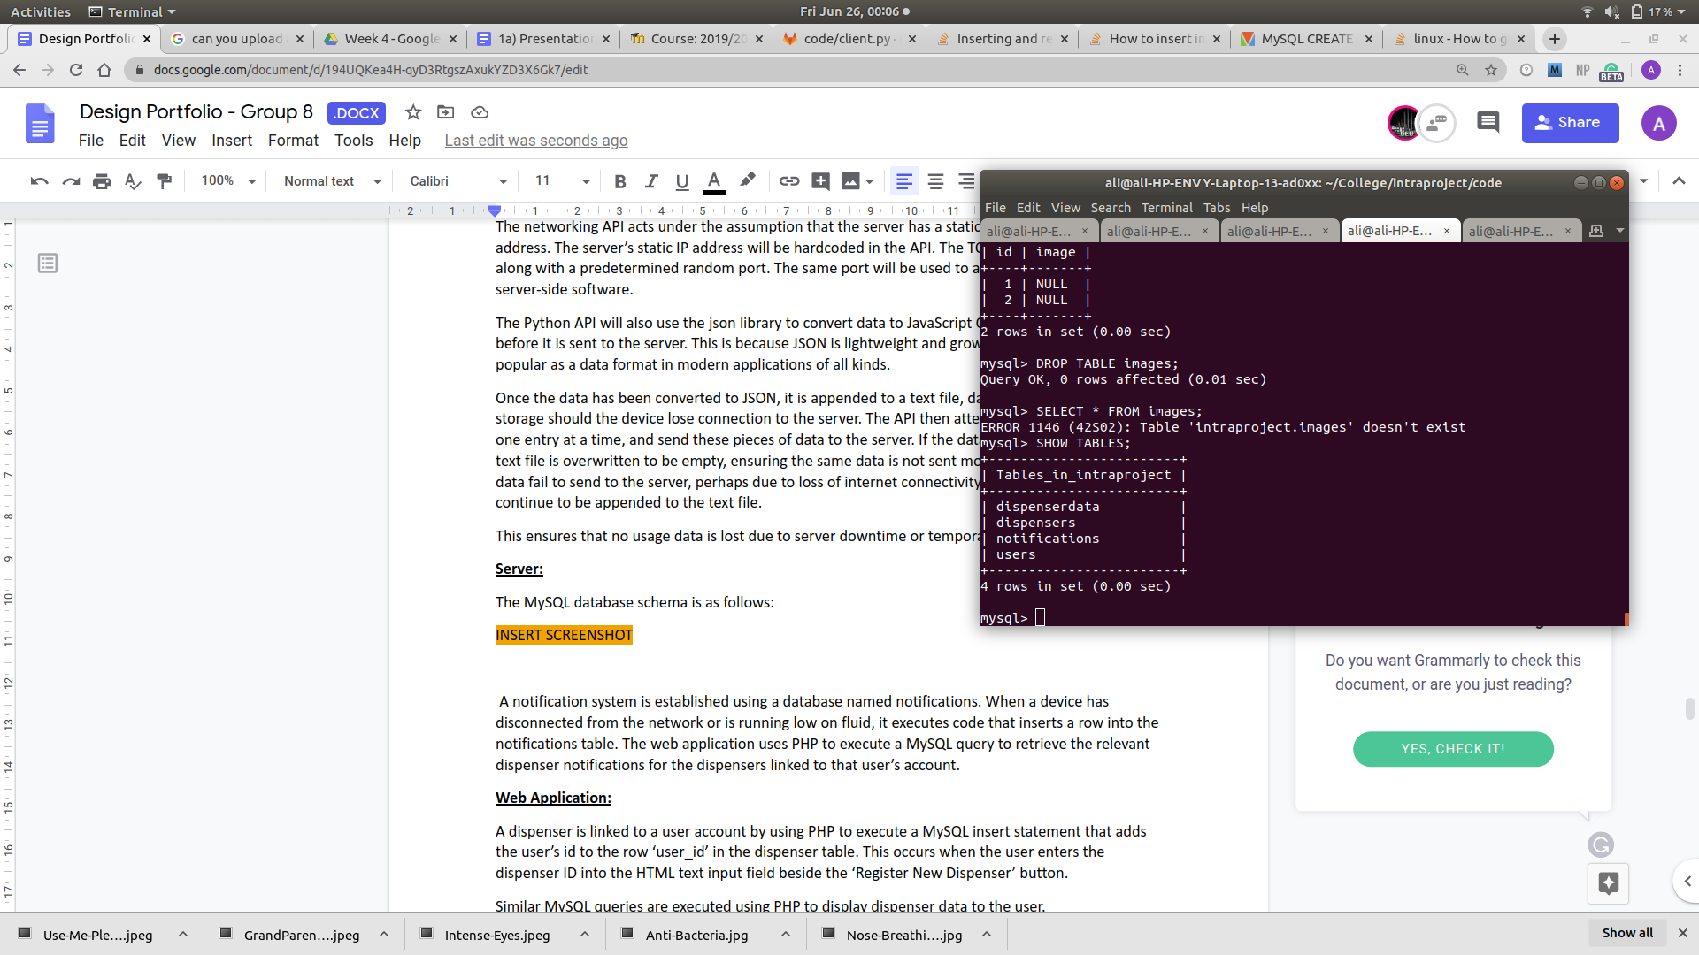 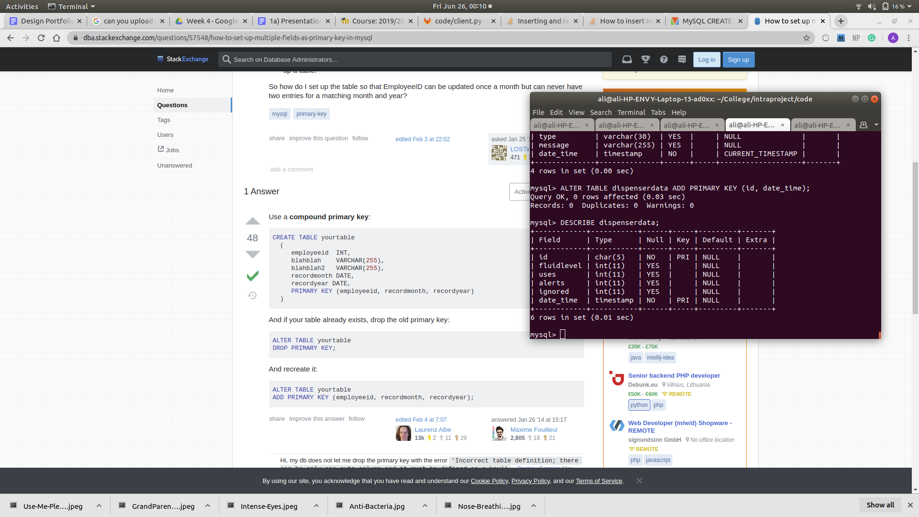

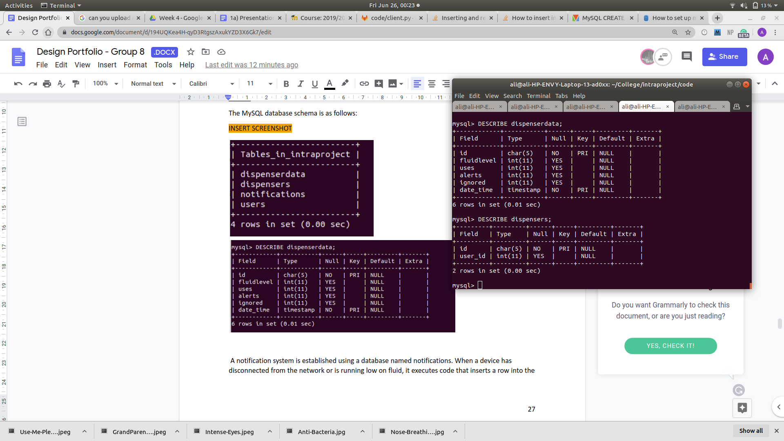

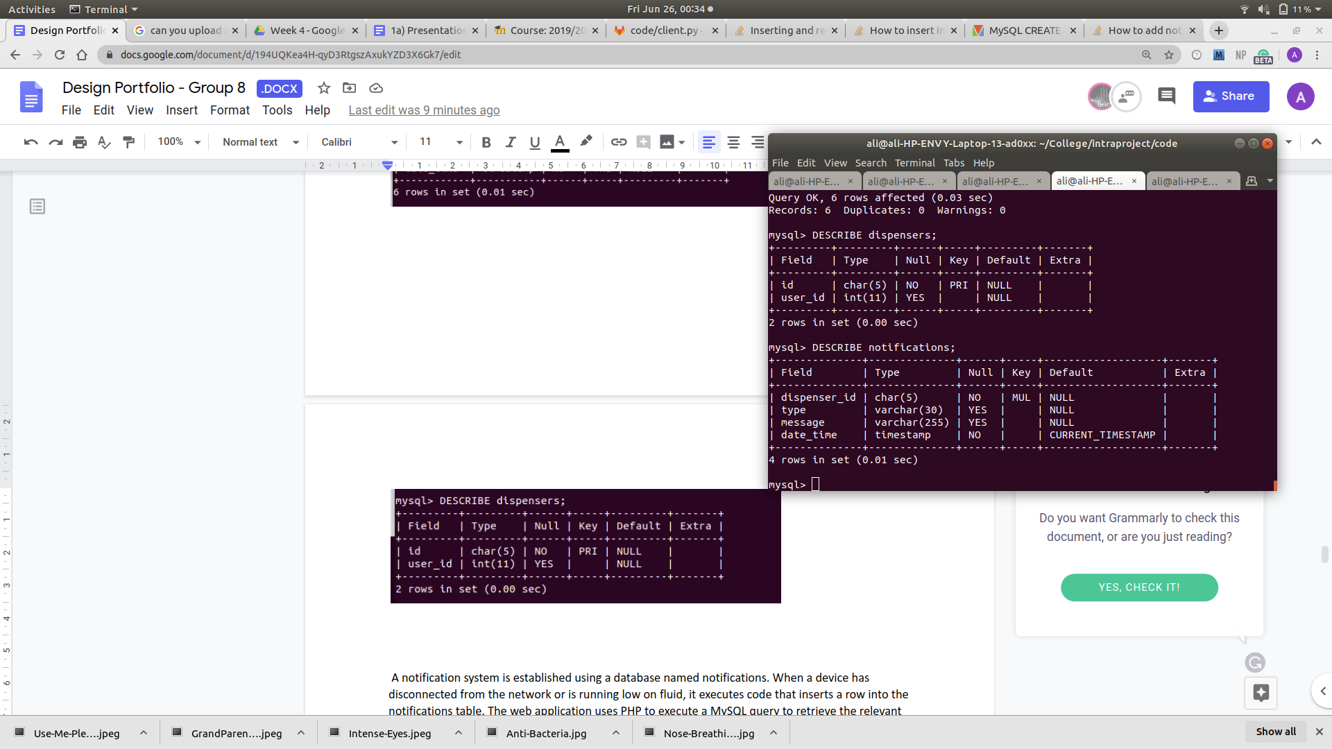

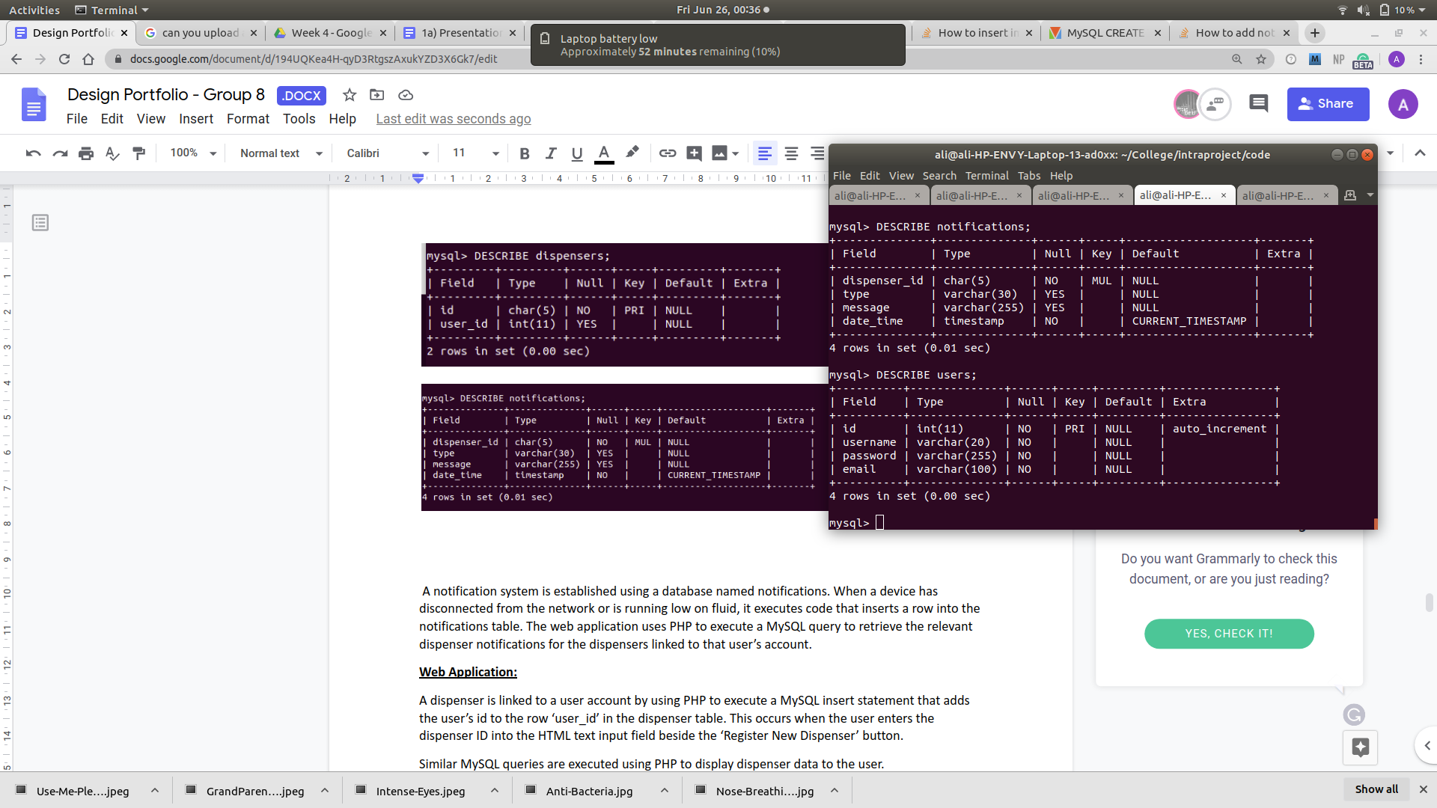

When the user begins the account creation process on the web application, their details are sent to the users table in the database through PHP. They are automatically assigned a user ID, which is used as the primary key. For security purposes, the user’s password is hashed before it is stored in the database.

The dispensers table has two fields; id and user_id. This table keeps track of the devices on the network as well as providing a method for creating a relation between users and their dispensers. When a dispenser first comes online it announces itself to the network. The server software checks if the device id is already in the dispensers table, and adds it if it is not.

The relevant user’s id is added to the user_id field when they register the dispenser to their account using the web app. This is discussed in further detail below.

The dispenserdata table contains individual updates of every dispenser on the network’s usage data. The primary key for this table is the combination of id and date_time.

Upon device usage data, the server software converts the incoming JSON string to a JSON object. The elements of the object are placed in a MySQL statement, which inserts this information into the dispenserdata table.

A notification system is established using a database named notifications. When a device has disconnected from the network or is running low on fluid, it executes Python code that inserts a row into the notifications table. The web application uses PHP to execute a MySQL query to retrieve the relevant dispenser notifications for the dispensers linked to that user’s account.

**Web Application:**

As previously mentioned above, user account creation is made possible through the use of HTML and PHP.

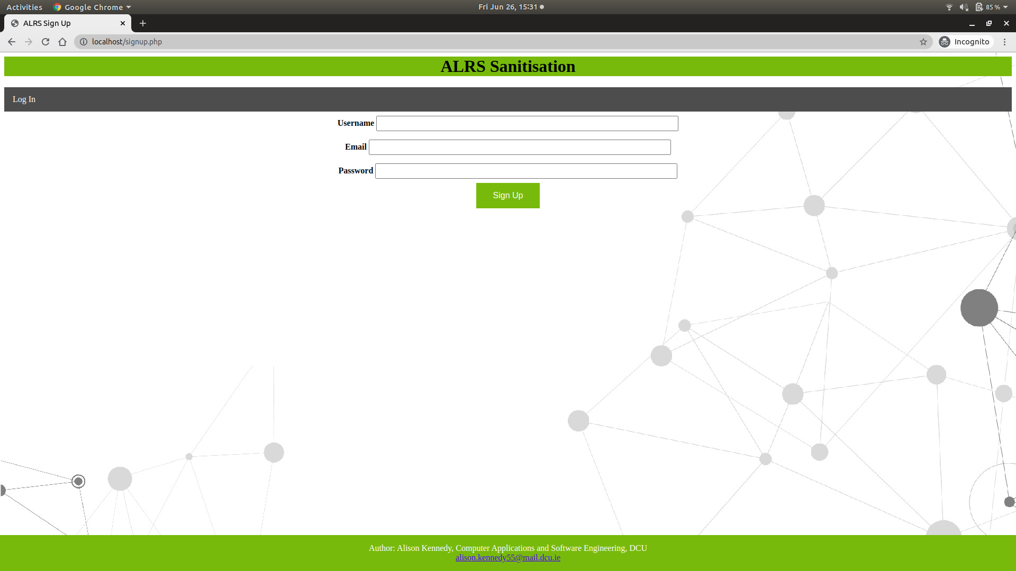

The user enters their username, email address, and password in the relevant fields as shown above. The HTML form used to acquire this information passes this data to a PHP script. The registration script executes MySQL queries to check if the user already exists, and inserts their details into the users table if not. For security purposes, the user’s password is hashed using the built in PHP password_hash function before it is added to the database. A user ID, which automatically increments with each entry to the users table, is assigned. This id corresponds with the user’s session ID once they log in to the website.

A dispenser is linked to a user account by using PHP to execute a MySQL insert statement that adds the user’s id to the row ‘user_id’ in the dispenser table. This occurs when the user enters the dispenser ID into the HTML text input field beside the ‘Register New Dispenser’ button.

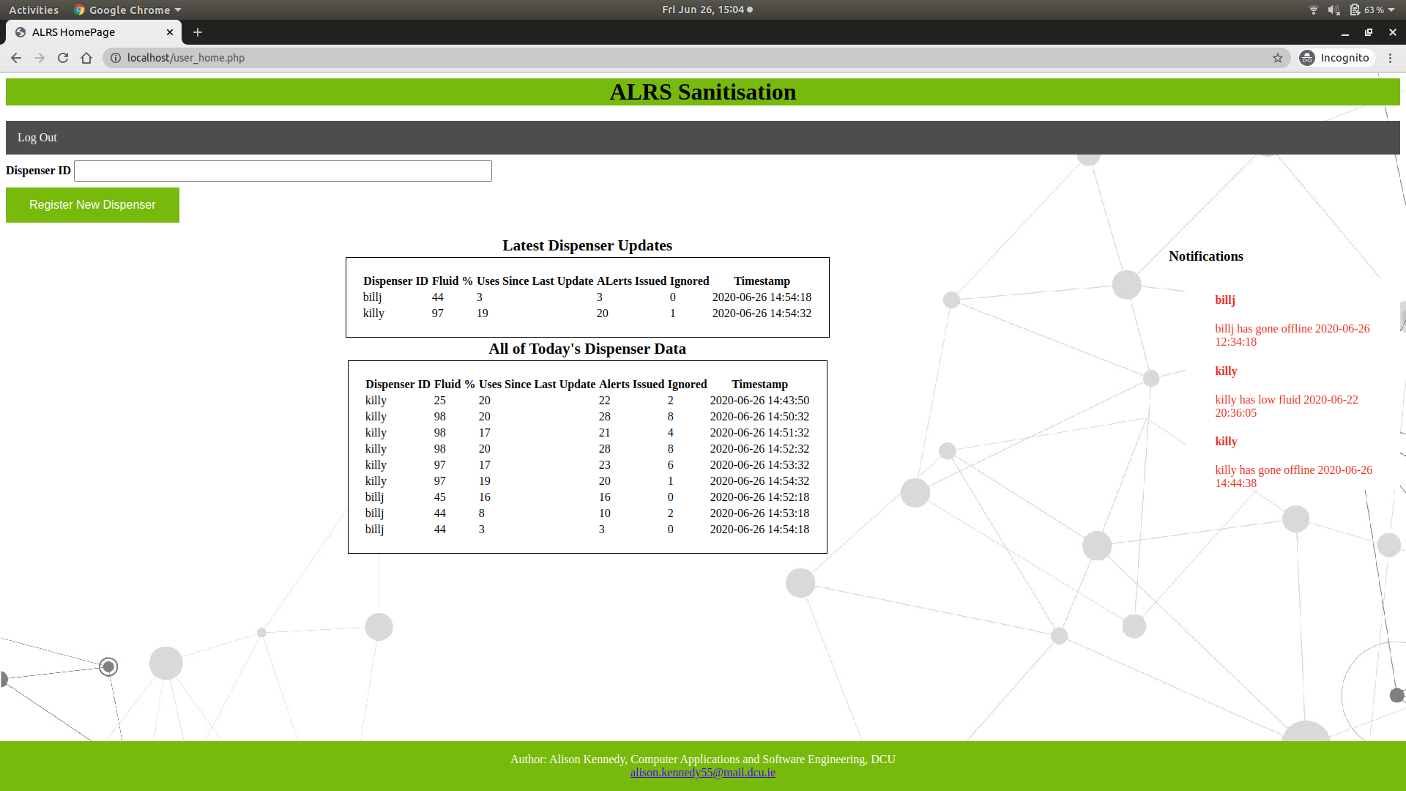

Similar MySQL queries are executed using PHP to display dispenser data to the user. The current prototype displays the latest update for every device registered to the user. All updates with today’s date are also displayed in a HTML table.

Notifications can also be found on the right hand side of the page. Again, PHP is used to execute a MySQL statement and retrieve the result to display to the user.

**Further Development:**

Due to time constraints and the loss of a member of the School of Computing, not all aspects of the software design could be prototyped before the deadline. The complete design and possible implementation methods include:

1. **An element of data analysis**

The MySQL dispenserdata table can be analysed in respect to each user. The analysis could bring to light which dispenser on the network is most used, least used, most ignored etc. This could be achieved entirely through the use of PHP and MySQL statements, or by writing a Python script to analyse the data. This information could be displayed on the user’s homepage using PHP.

1. **Artificial intelligence**

The mechatronic design includes an LED screen placed on the front of the device. This screen will be used to display persuasive imagery, in hopes of attracting more people to use the device and lower the spread of infection. Examples of such images can be found in the GitLab repository.

A rule based system can be established which analyses the effectiveness of each image in their environments. For example, the AI might conclude that school children were most persuaded to use the device when the image of elderly grandparents appeared on the screen.

# Failure Modes and Effect Analysis (FMEA)

This type of analysis is carried out in order to consider possible problems that may arise, and to consider how these problems may be mitigated.

First, we will define the failure modes associated with the device. Then, each failure mode will be assessed using a FMEA table. This table gives us some very useful information about any possible failure risks. Through the Risk Priority Number (Explained below), we can determine what priority our potential risks could be, therefore allowing us to know where to invest more time & money into the manufacture and service of various components.

For example, the calculated RPN for corrosion of the device is 24 out of 1000, which gives us a percentage (for simplicity) of 2.4%. This is clearly not a risk of utmost importance. However, fatigue failure has an RPN of 84 out of 1000, highlighting it to be a bigger risk. Due to this fact, we (the manufacturers) may decide to increase spending on material strength by potentially adding a double sheet of material in the most used places on the device.

Decisions which increase price will always need a sound justification, and the FMEA table provides exactly that. However, the FMEA table gives us more than a justification of an increase in costs. It also provides us with an in depth analysis of all possible modes of failure or risk associated with the product, allowing us to include the relevant safety documentation and warnings of risks for the future users.

The table Legend is as follows:

Failure:What may cause the device to fail?

Effect:What will happen due to this failure?

Cause:What is the cause of this failure?

S:Severity Rating - How severe would the failure be ( 1: No injury, 10: death)

O:Occurrence Rating - How likely is it to happen ( 1: Not likely, 10: Expected)

D:Detection Rating - How easy is it to detect? ( 1: Will be detected, 10: Impossible)

RPN:Risk Priority Number (RPN = S*O*D) - How high priority is the risk

The tables and their analyses can be located on the pages following from each perspective (Mechanical, Electrical, and Computer).

**Mechanical Perspective**

* Corrosion (Due to corrosive hand sanitising liquid)
* Fatigue Failure (Failure due to usage)
* Wall Mount Failure (Failure due to wall mount)

|  |  |  |  |  |  |  |
| --- | --- | --- | --- | --- | --- | --- |
| **Failure** | **Effect** | **Cause** | **S** | **O** | **D** | **RPN** |
| Fatigue Failure | Causes moving parts to wear down over time and eventually fail | As time increases, so too does the usage of the device (we hope). This can lead to material failure. | 4 | 7 | 3 | 84 |
| Corrosion | Causes defects in device wherever the failure occurs | Hand sanitising solution is approximately 70% alcohol, which can be corrosive | 3 | 4 | 2 | 24 |
| Wall Mount Failure | Causes the device to fall from the wall to the floor, ruling out any possible usage. | Could be due to lateral pressure being applied and removed consistently over long periods of time. | 5 | 2 | 1 | 10 |

**Electrical Perspective**

* Power loss
* Sensor Failure
* Damaged cables
* Damaged electronics

|  |  |  |  |  |  |  |
| --- | --- | --- | --- | --- | --- | --- |
| **Failure** | **Effect** | **Cause** | **S** | **O** | **D** | **RPN** |
| Power loss | Causes the device to hard reset or become inactive. | Problems can occur in the power supply or main board. | 3 | 5 | 1 | 15 |
| Sensor failure | Causes the device to manifest malfunctions while reading the data resulting in not dispensing the fluid. | Aged electronics or environmental factors cause most of the failures. | 2 | 3 | 3 | 18 |
| Damaged cables | Causes the device to lose communication with specific parts, can result in complete failure of the device. | Quality of the cables or accidents which result in the cables being damaged during the normal maintenance process. | 3 | 3 | 2 | 18 |
| Damaged electronics | Causes the device to not dispense the fluid or to not sense when a person who tries to use it, even can cause the device to not be able to be powered. | Age of the lectronics, user error, environmental problems (humidity). | 2 | 2 | 2 | 8 |

**Computer Perspective**

* Network Connection Loss
* Server down
* Power loss
* Sensor/component failure

|  |  |  |  |  |  |  |
| --- | --- | --- | --- | --- | --- | --- |
| **Failure** | **Effect** | **Cause** | **S** | **O** | **D** | **RPN** |
| Software Logical Error | Causes the usage data gathered to be inaccurate | Illogical code | 3 | 2 | 7 | 42 |
| Network Connection Loss | Causes the device to lose the channel of communication with the server and web app. | WiFi router may lose power or there may be an ISP problem | 3 | 3 | 2 | 18 |
| Sensor/  component Failure | Causes the device either to be unable to dispense fluid or unable to gather accurate usage data | Aging and fatigue | 2 | 2 | 4 | 16 |
| Server Down | Causes the web app to be inaccessible. The dispenser also cannot update the database. | Power failure, system overload, cyber attacks | 3 | 3 | 1 | 9 |
| Power Loss | Causes the device to be unable to dispense sanitising fluid or collect usage data. | External or internal power supply issues | 3 | 2 | 1 | 6 |

# Conclusions

The contents of this design portfolio prove to show that the development of a smart hand sanitising system, as described above, is more than feasible in terms of mechanics, electrics, software, cost, and environment.

**Mechanics:**

The physical casing and associated elements of the device can be manufactured, through the methods detailed above, in a way that is sleek and appealing, yet environmentally friendly and cost conscious. The device can be manufactured to be safe, stable and intuitive, for the optimum satisfaction of the end user.

**Electrics:**

The components of the electrical engineering design, as showcased above, show that the hardware and wiring necessary to develop the design are widely available and easily implemented.

**Software:**

Though the final design could not be implemented fully in the given time frame, it is evident that the design is more than feasible in a slightly longer window. The technologies required are widely available, heavily documented and easily implemented.

# References

[1] “The product design specification (PDS)”, designandmanufacturing - trimurtulu, 2007. [Online]. Available: <http://designandmanufacturing-trimurtulu.wikifoundry.com/page/The+product+design+specification+%28PDS%29>. [Accessed: 21 - June - 2020]

# Appendices

**Technical Drawings**

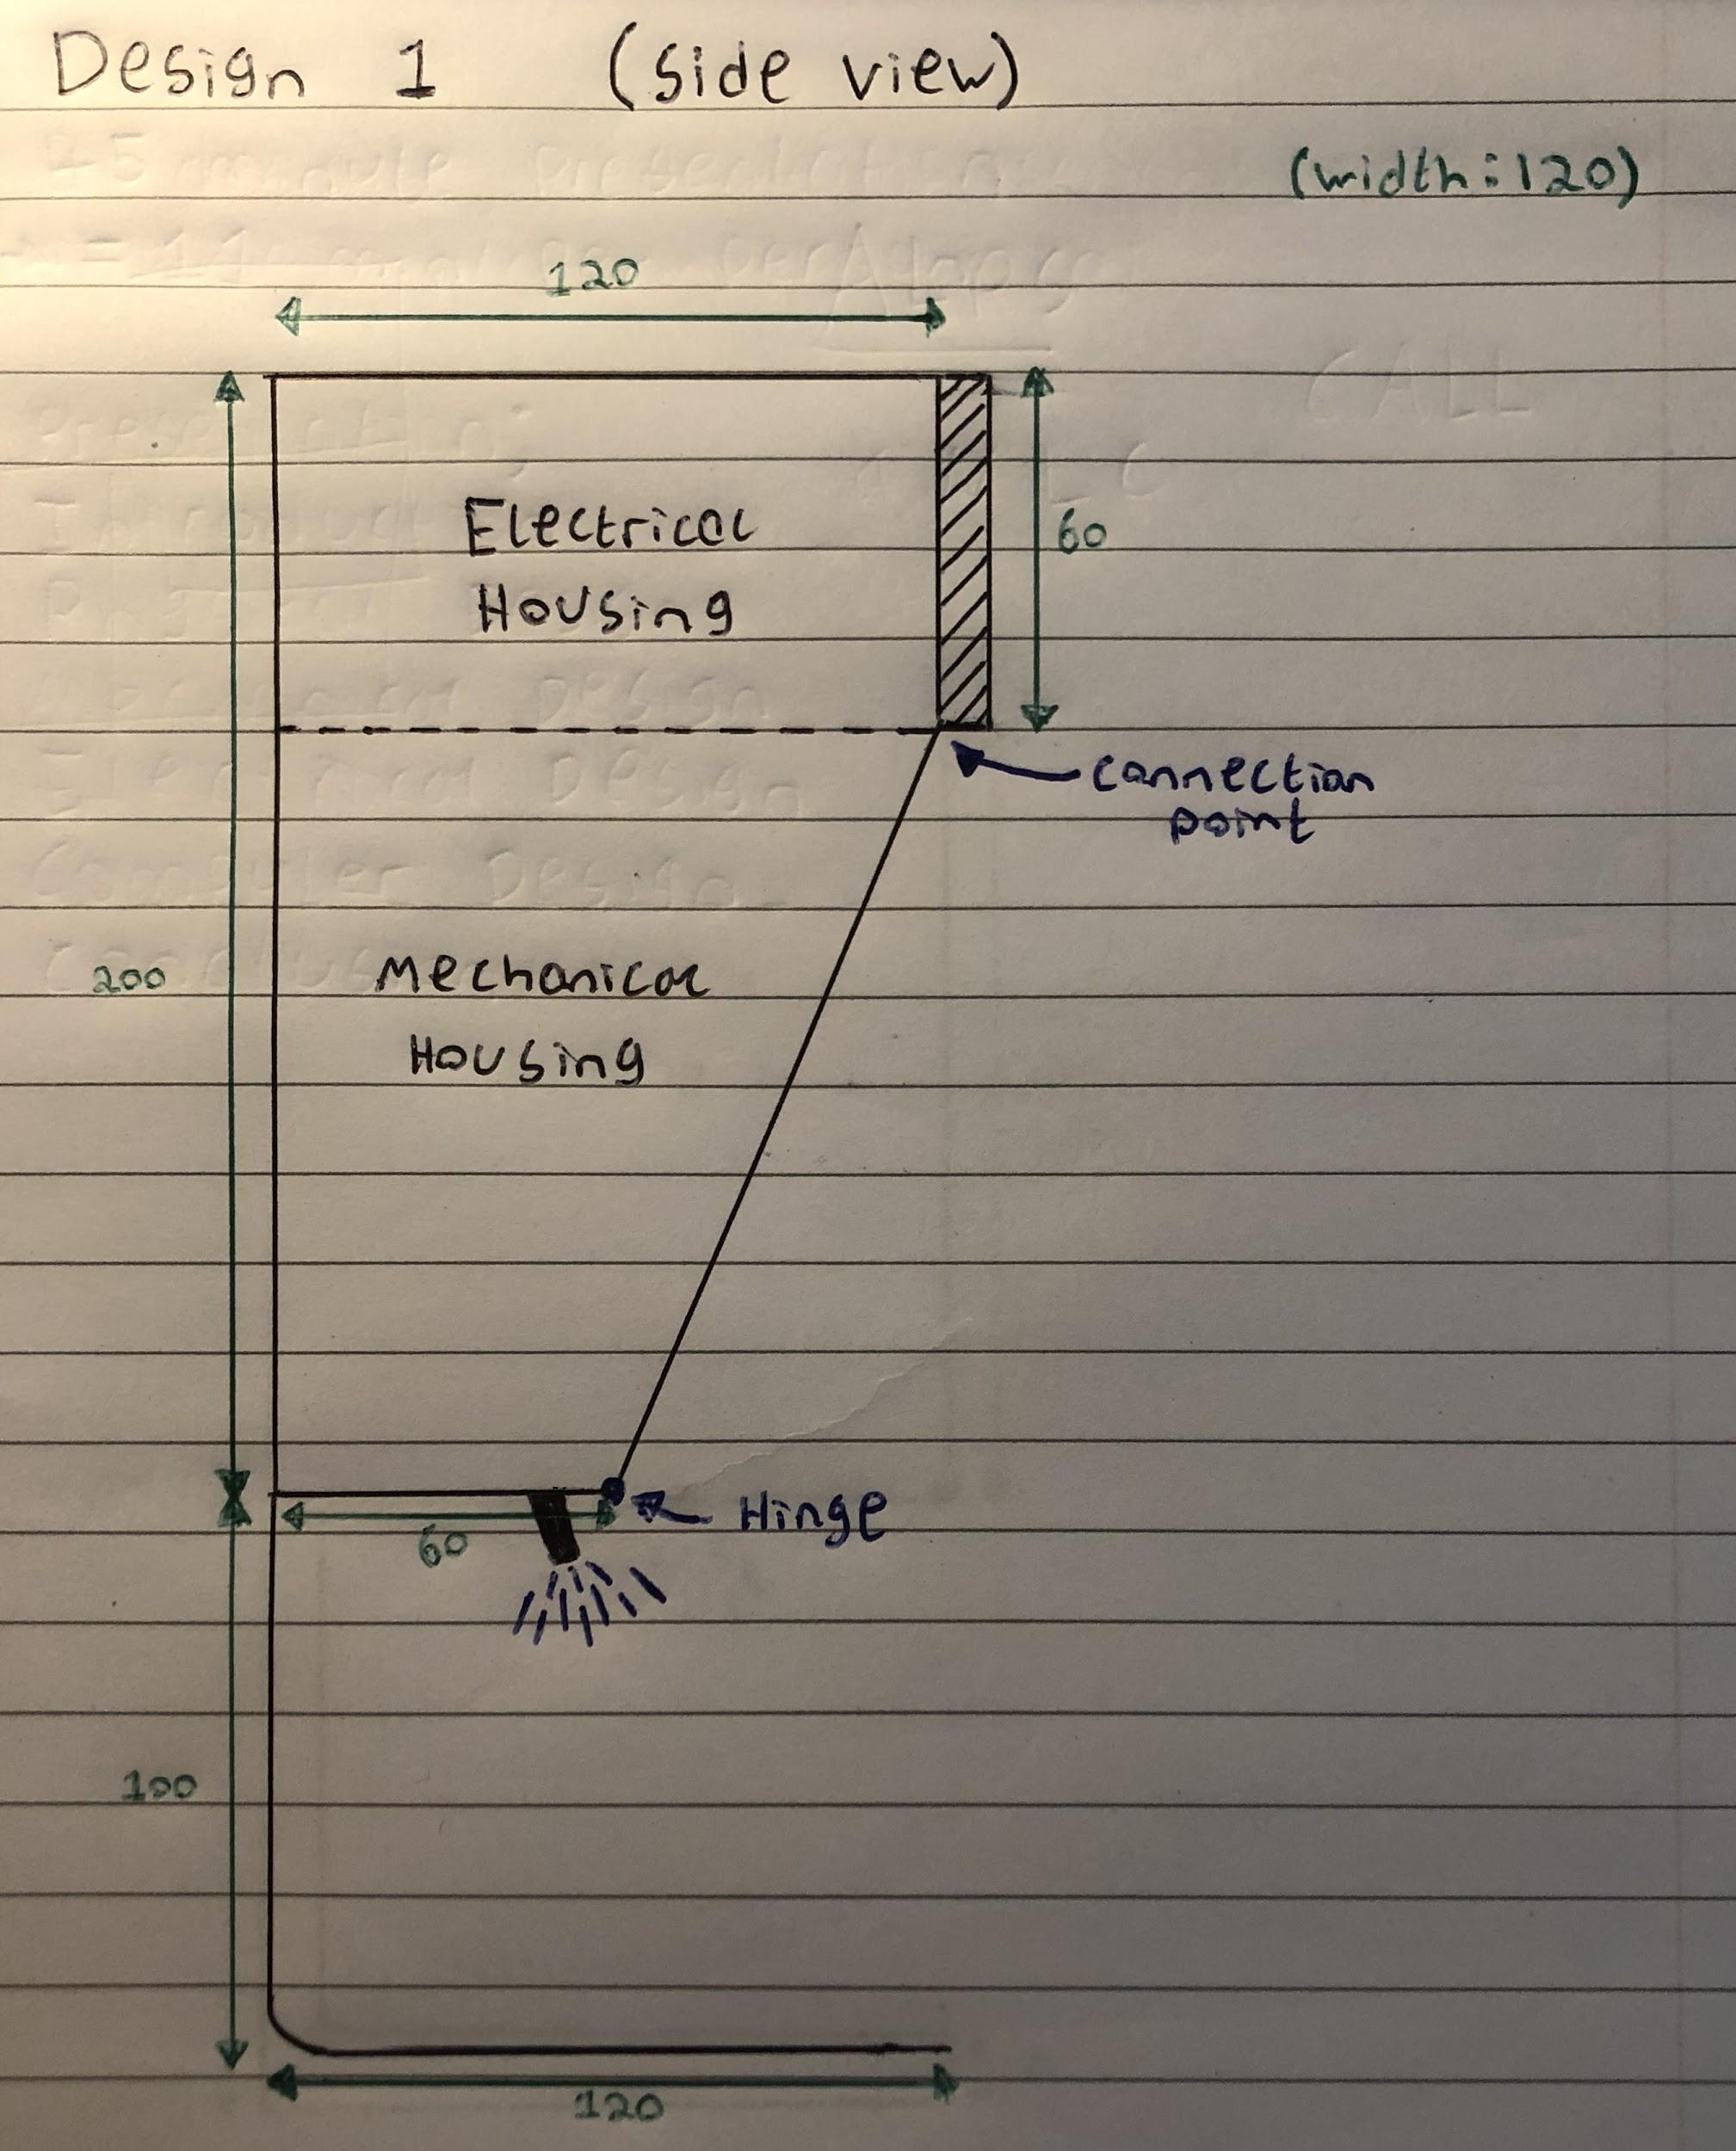 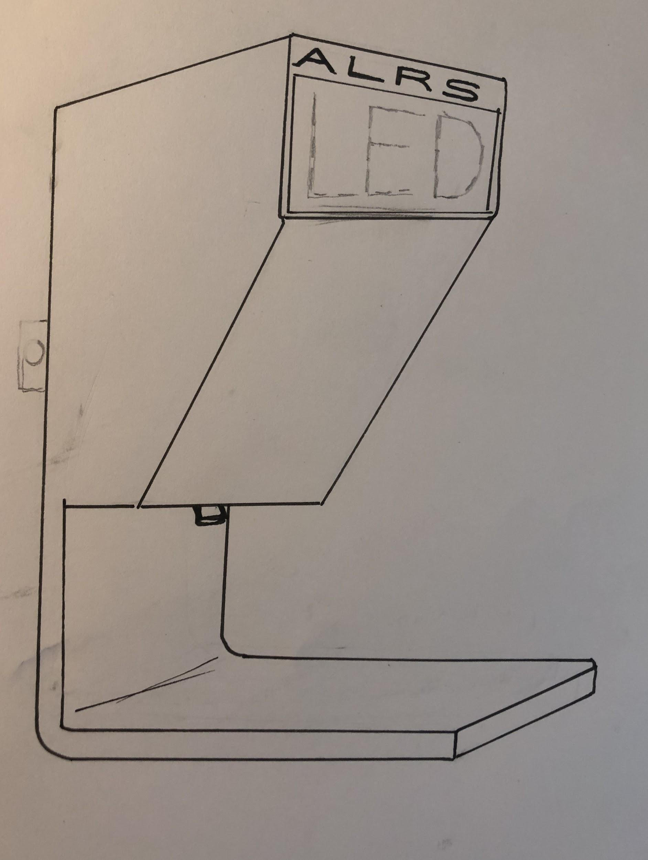

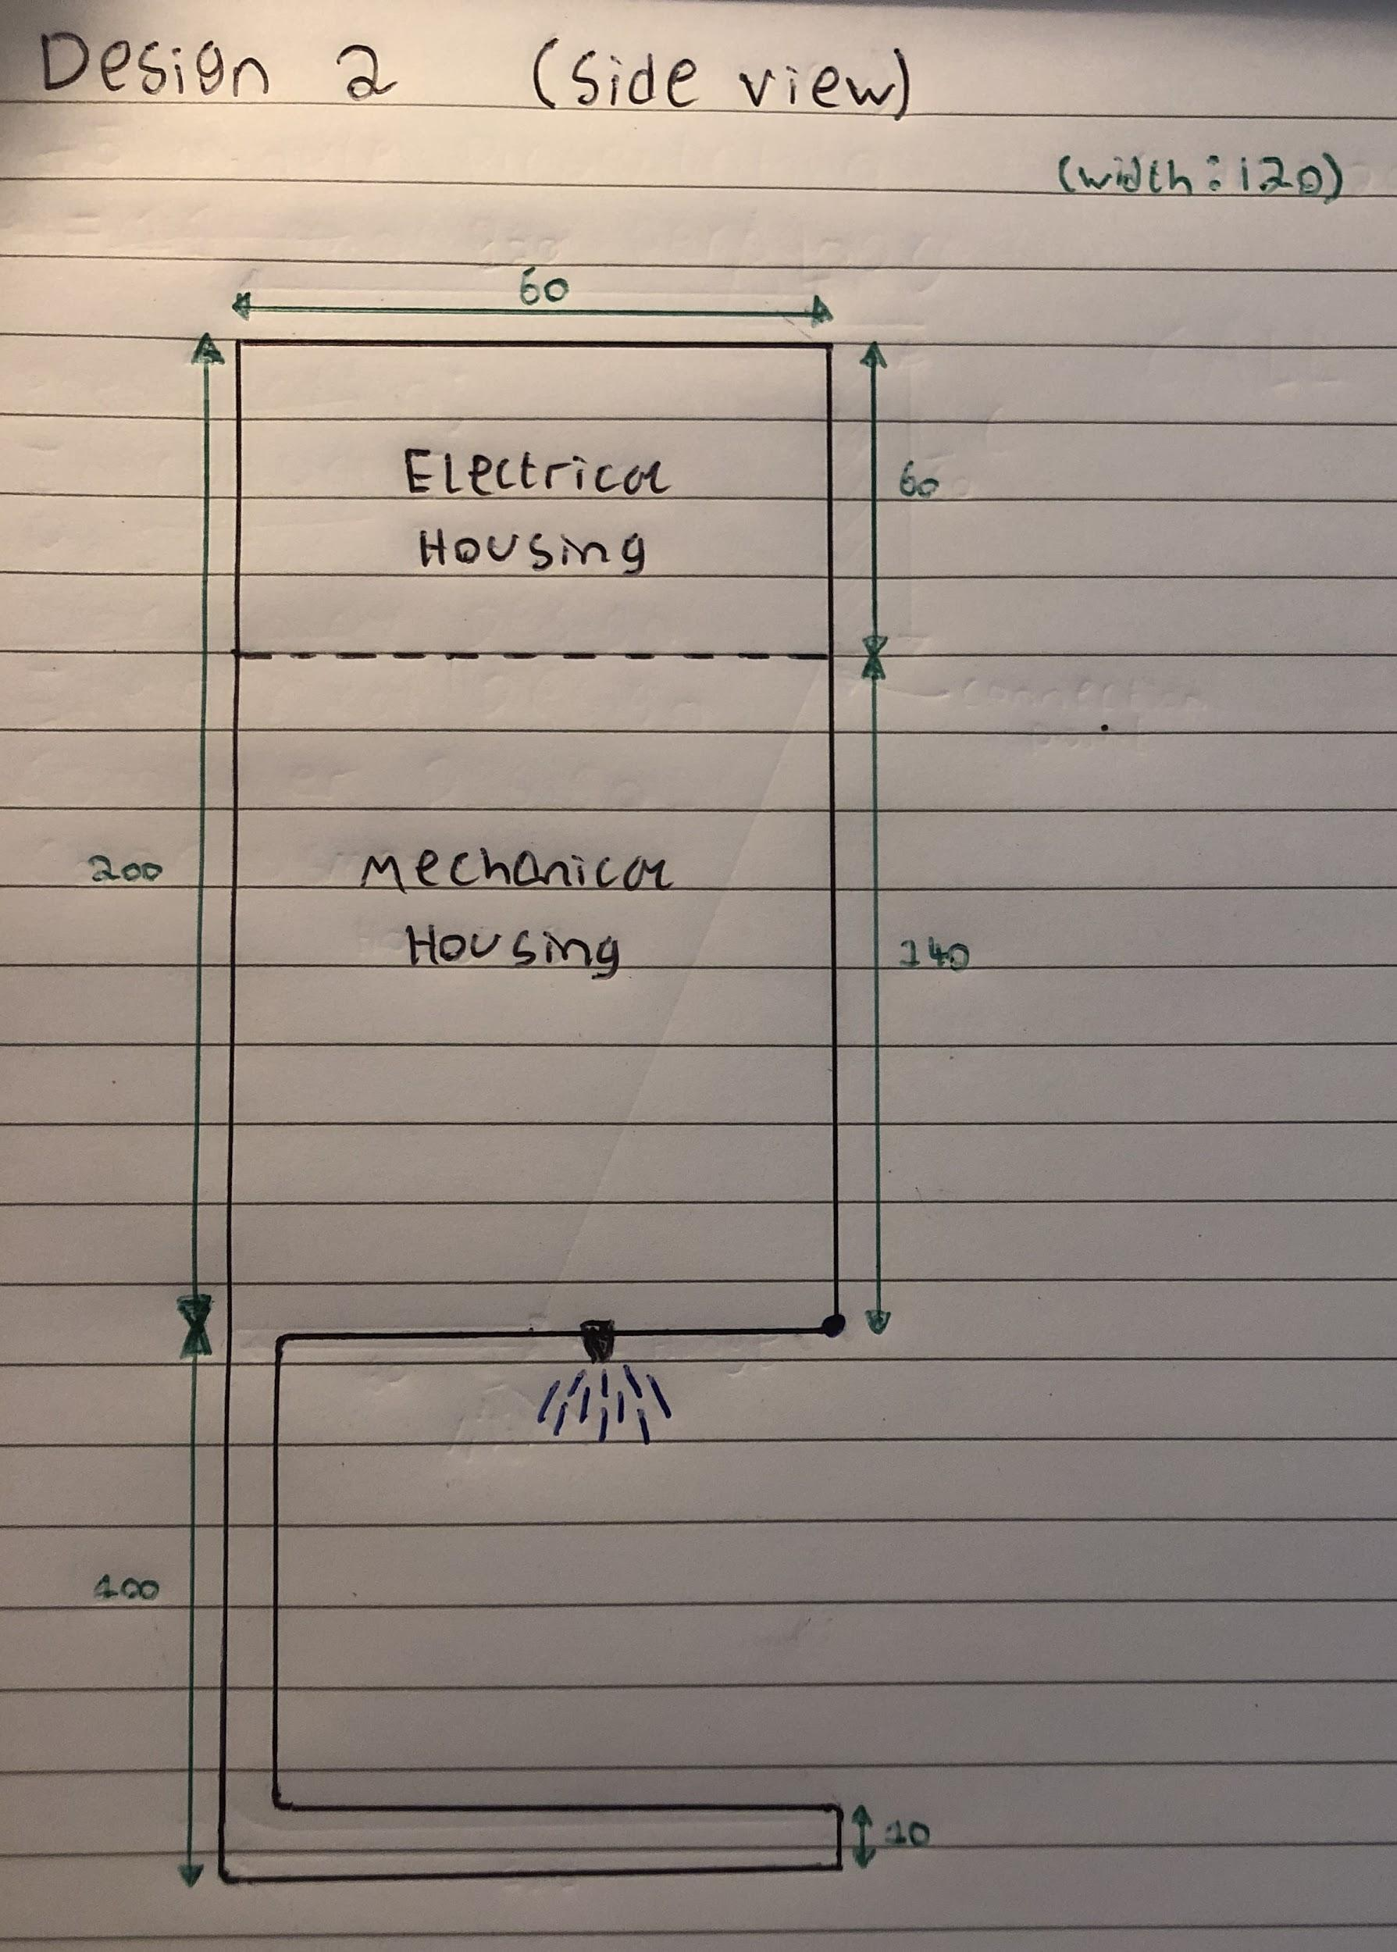 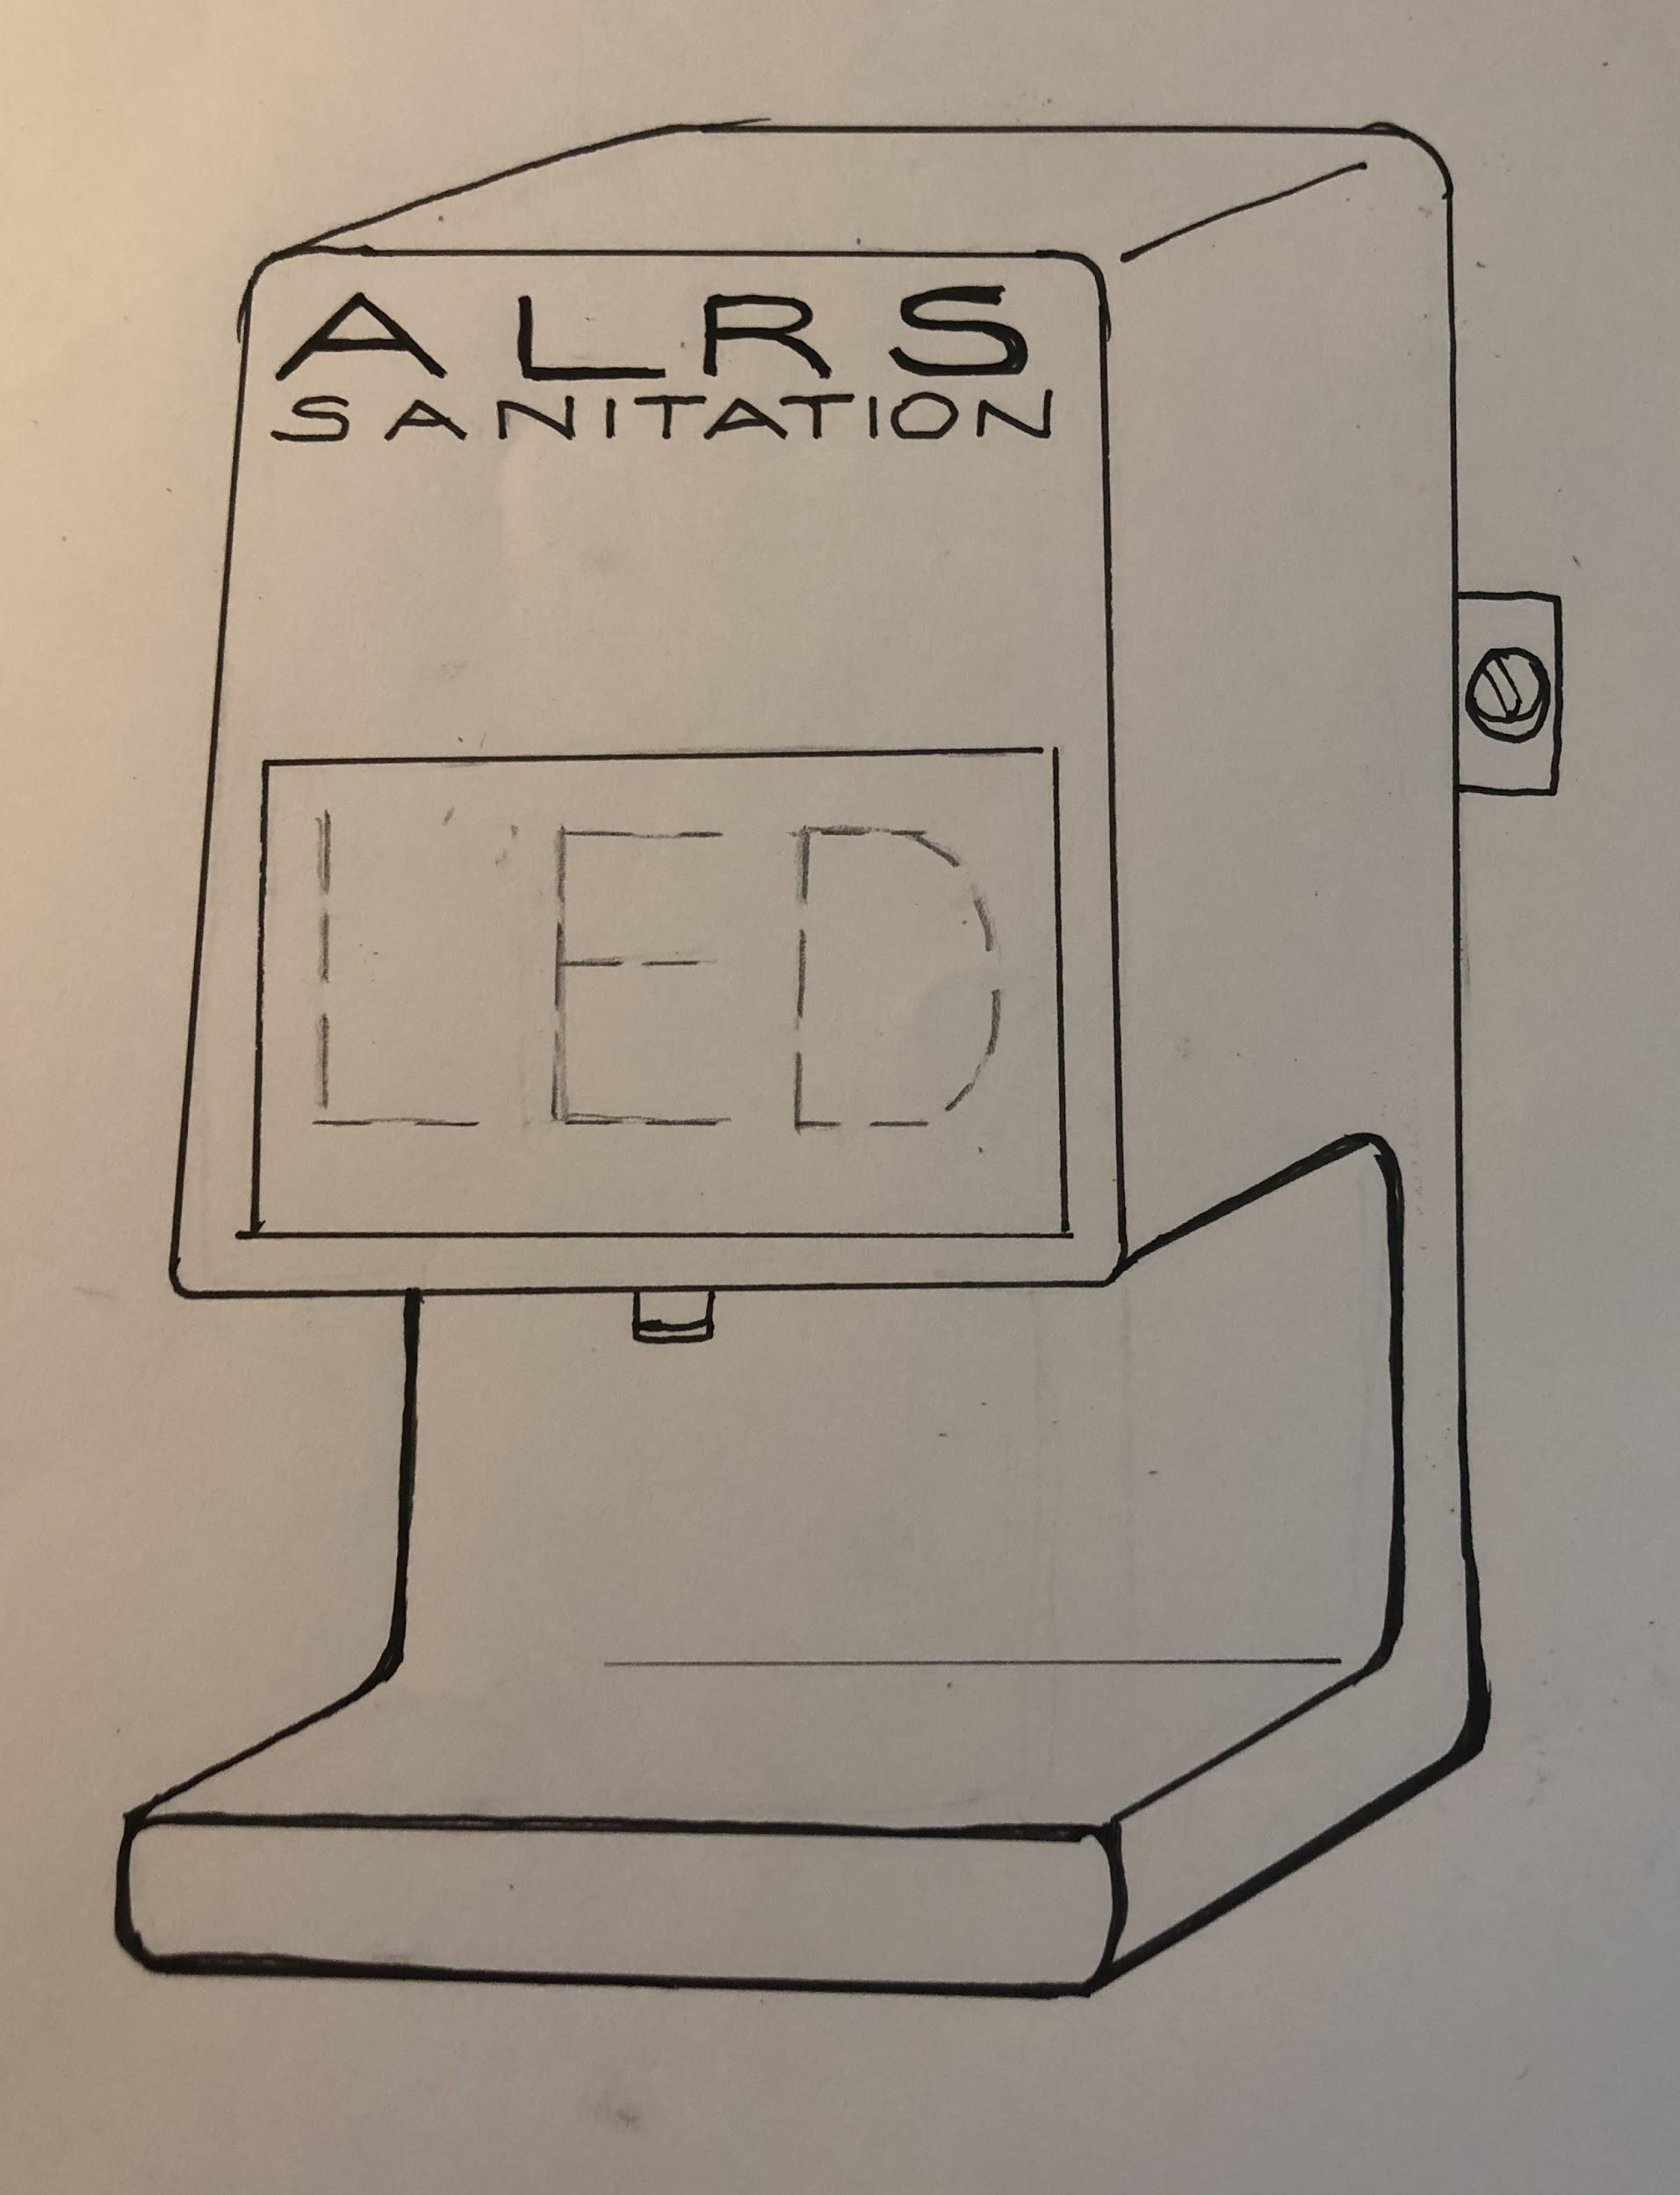

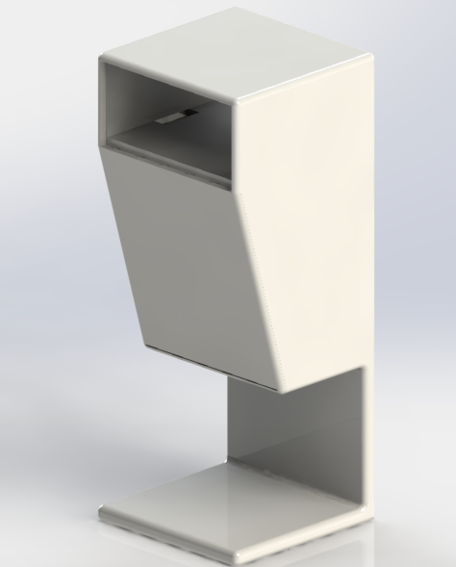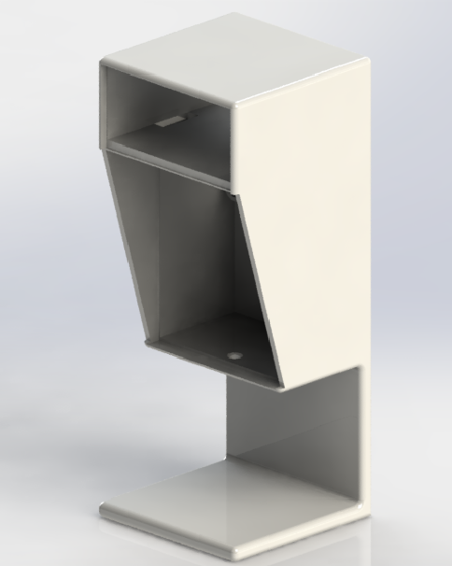

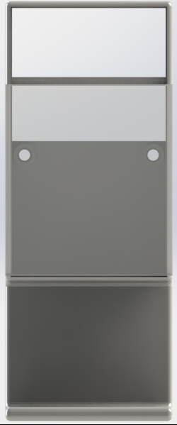 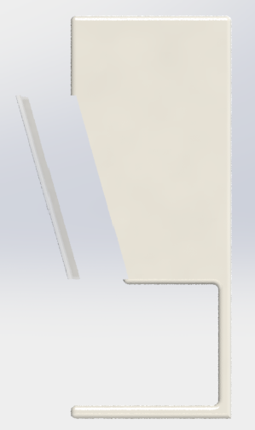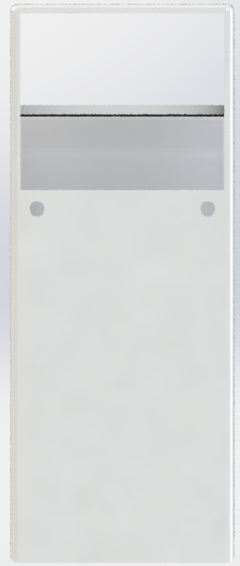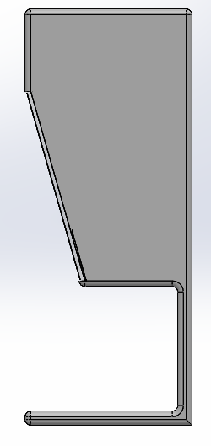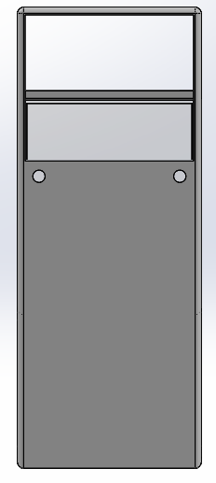

**electronic circuit drawings**

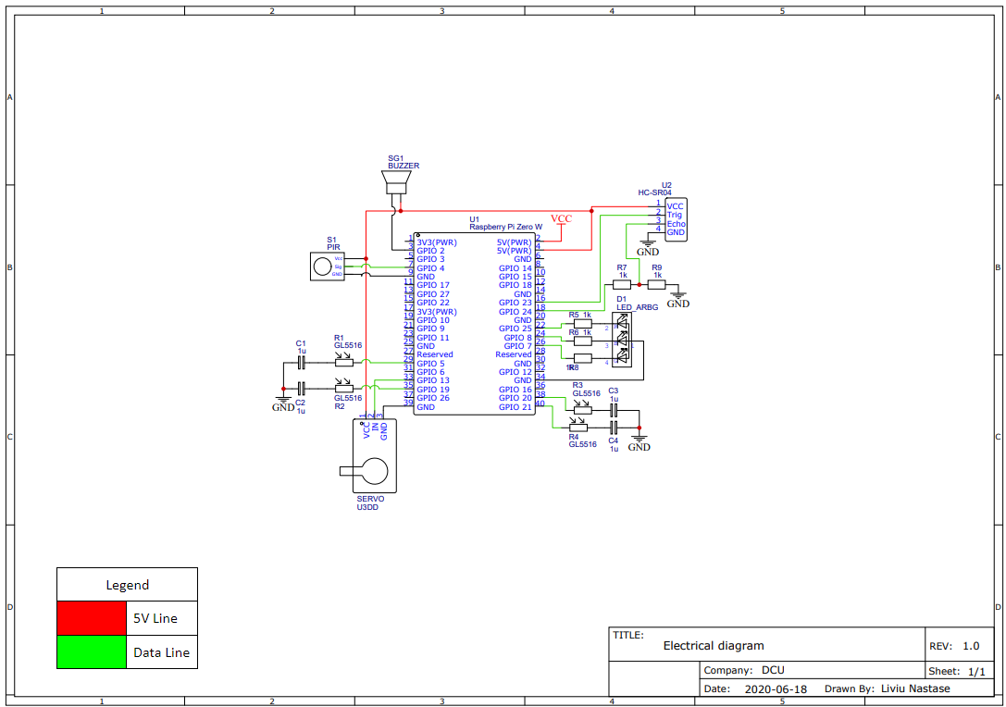

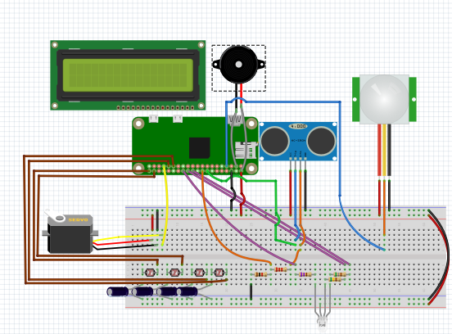

**Software Code**

Software code for the current prototype can be found at this link: <https://gitlab.computing.dcu.ie/kennea55/intraproject>

**Bill of Materials (component list and suppliers with costings)**

This bill will be on a “per-piece” basis.

**Mechanical ComponentsSupplierPrice**

ABS PlasticAlbaba2 euro per kilogram

Screws (X2)RS Supplies3 euro for 100 screws

Adhesive strips (X2)RS Supplies5.56 euro for 3 metres

Rack & Pinion3-D PrintCheap per unit

**Electrical SupplierPrice**

Wiring22 AWG 8 euro for 100m

<https://www.jameco.com/webapp/wcs/stores/servlet/ProductDisplay?langId=-1&storeId=10001&productId=36768&catalogId=10001>

Circuit BoardEasyEDA0.42 euro per pcb

<https://jlcpcb.com/?gclid=CjwKCAjwltH3BRB6EiwAhj0IUF0hTVjP0rzNpAkVdqoyxEC1tCz9Evzmai6q7UvUehcnNfuS1BNSohoCAw0QAvD_BwE>

Servo MotorTowerPro1.8 euro per servo

<https://uk.banggood.com/TowerPro-SG90-Mini-Gear-Micro-Servo-9g-For-RC-Airplane-Helicopter-p-1009914.html?gmcCountry=IE&currency=EUR&createTmp=1&utm_source=googleshopping&utm_medium=cpc_bgs&utm_content=haosen&utm_campaign=haosen-pla-ie-toys-rcparts-pc-0508&ad_id=434708630819&cur_warehouse=CN>

Ultrasonic sensorGeekcreit1.21 euro per sensor

<https://uk.banggood.com/Wholesale-Geekcreit-Ultrasonic-Module-HC-SR04-Distance-Measuring-Ranging-Transducers-Sensor-DC-5V-2-450cm-p-40313.html?gmcCountry=IE&currency=EUR&createTmp=1&utm_source=googleshopping&utm_medium=cpc_bgcs&utm_content=haosen&utm_campaign=pla-ieg-all-pc-1101&ad_id=338313631608&gclid=CjwKCAjwltH3BRB6EiwAhj0IUNI_NdmLJJOIZwL9puW-oYMYzX6bSFLpbR4BN7owlTHbU9FmDP-meRoCCGQQAvD_BwE&cur_warehouse=CN>

PIR sensor ARCELI 1.1 euro per sensor<https://uk.banggood.com/HC-SR501-Adjustable-Infrared-IR-Pyroelectric-PIR-Module-Motion-Sensor-Human-Body-Induction-Detector-p-1545488.html?akmClientCountry=IE&rmmds=cart_middle_products&cur_warehouse=CN>

**Computer**

Raspberry Pi Raspberry Pi 8 euro per board with a 10-15% bulk discount <https://thepihut.com/products/raspberry-pi-zero-w?src=raspberrypi>